BUDAPEST UNIVERSITY OF TECHNOLOGY AND ECONOMICS
Faculty of Chemical Technology and Biotechnology
2024/2025, 1st semester

First classes: 2 September (Monday)

Last casses: 6 December (Friday)

Days off: 17 September (Tuesday, BME Sport day), 23 October (Wednesday, National festival day), 1 November (Friday, National festival day), 21 November (Thursday, „TDK” day), 29 November (Friday, „Open day”)

Dean’s holiday: 23 September (Monday)

Replacement period: 9-13 December (Monday-Friday)

Examination period: 16 December-20 December
6 January-24 January

Subject code | Subject name | Lecturer(s) | Course code | type |  | cr | lect | sem | lab | Schedule
BMEGT30A001 | Micro- and Macroeconomics | Zoltán Bánhidi  Dr. Zsolt Gillányi | EEN44BM | theo | e | 4 | 4 | 0 | 0 | Mo:08:15-10:00(QAF14); Mo:10:15-12:00(QAF14)
BMEGT60Z941 | English for Chemical Studies 1. | Dr. Nóra Wenszky  Mónika Kiss | Sz8P11_Chem1; Sz8P11_Chem1_2 | pract | p | 3 | 0 | 4 | 0 | We:08:15-10:00 (E807);  Fr:11:15-13:00 (E807)
BMEVESAA103 | Computing | Gyula Jágerszki | Gy16eng | pract | p | 2 | 0 | 2 | 0 | Th:08:15-10:00 (R4A)
BMEVESAA101 | General Chemistry | Dr. Zoltán Benkő,  Dr. László Nyulászi | E36eng | theo | e | 5 | 4 | 0 | 0 | We:10:15-12:00(CH308); Th:10:15-12:00(CH308)
BMEVESAA104 | General Chemistry Calculations for Chemical Engineers | Dr. Zoltán Benkő, Dr. Júlia Kertész, Rozza Ahmed Mohamed | A01eng | pract | p | 4 | 0 | 3 | 0 | Mo:14:15-16:00 (CHA10)  Fr:08.15-10.00(CH304, CH301)
BMEVESZA101 | Industrial Safety | Dr. István Csontos, Dr. László Hegedűs | 25a | theo | p | 2 | 2 | 0 | 0 | We:12:15-14:00 (CH307)
BMETE90AX00 | Mathematics A1a - Calculations | Noorafkanzanjani Azam | EN-VBK-0, EN-VBK-1 | theo, pract | e | 6 | 4 | 2 | 0 | We:16:15-19:00(CH302); Th:16:15-19:00(CHA11)
BMEVETOA050 | Study Group Course |  | Eng (BSc) | pract | s | 0 | 0 | 2 | 0 | Th:13:15-15:00(CHA10)

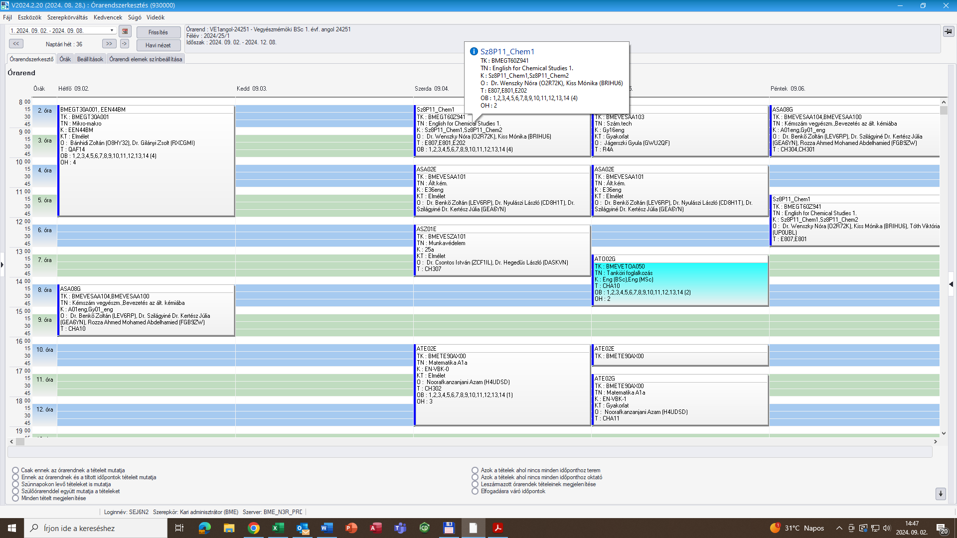

Subject code | Subject name | Lecturer(s) | Course code | type |  | cr | theo | pract | lab | Schedule
BMEVEFAA306 | Plastics | Dr. Alfréd Kállay-Menyhárd,  Dr. János Móczó | theory-ENG | theo | p | 5 | 2 | 0 | 2 | Mo:8:15-10:00 (CH301)
BMEVEFAA306 | Plastics | Dr. Dóra Tátraaljai, Dr. Alfréd Kállay-Menyhárd,  Dr. János Móczó | lab-ENG | lab | p | 5 | 2 | 0 | 2 | Fr:13:15-17:00(HF4)
BMEVEFAA405 | Physical chemistry II | Dr. Mihály Kállay, Bence Hégely | A6-ER, A7-ER | theo, pract | e | 4 | 2 | 1 | 0 | Th:14:15-17:00(K150)
BMEGEVGAV03 | Chemical Engineering Fundamentals | Dr. Csaba Hős | EnE-AV03 | theo | e | 2 | 2 | 0 | 0 | Th:08:15-10:00 (K155)
BMEGEVGAV04 | Chemical Engineering Practice | András Szabó | EnL-AV04 | pract | p | 3 | 0 | 1 | 2 | We:08:15-10:00(L-HIDROLAB)
BMEVESAA302 | Analytical Chemistry I. | Dr. Ervin Róbert Gyurcsányi | 26eng | theo | p | 5 | 4 | 0 | 0 | Tu:14:15-16:00 (CH307); We:14:15-16:00 (CH305)
BMEVESAA301 | Inorganic Chemistry Laboratory Practice | Dr. Dénes Szieberth | L01eng.a8 | lab | p | 3 | 0 | 0 | 4 | Fr:8:15-12:00(CHALGS)
BMEVESZA301 | Organic Chemistry I. | Dr. József Attila Kupai  Dr Péter Ábrányi-Balogh | A29-ER,  A30-ER | theo, pract | e | 5 | 3 | 2 | 0 | Mo:10:15-12:00(CH-304)  We:12:15-14:00(CH306)
BMETE90AX18 | Mathematics A3c | Noorafkanzanjani Azam | EN-CA0 | theo | e | 4 | 2 | 2 | 0 | Mo:12:15-14:00 (CH 304)
BMETE90AX18 | Mathematics A3c | Noorafkanzanjani Azam | EN-CA1 | pract | e | 4 | 2 | 2 | 0 | Th:12:15-14:00 (CH 304),
BMEGT60Z943 | English for Chemical Studies 1. | Dr. Nóra Wenszky | H14K12_Chem3 | pract | p | 3 | 0 | 4 | 0 | Mo:14:15-16:00(E801); Tu:12:15-14:00(E705)
BMETE14AX04 | Physics 1E | Balázs Hetényi | C0A | theo | e | 2 | 2 | 0 | 0 | We:10:15-12:00 (CH305)

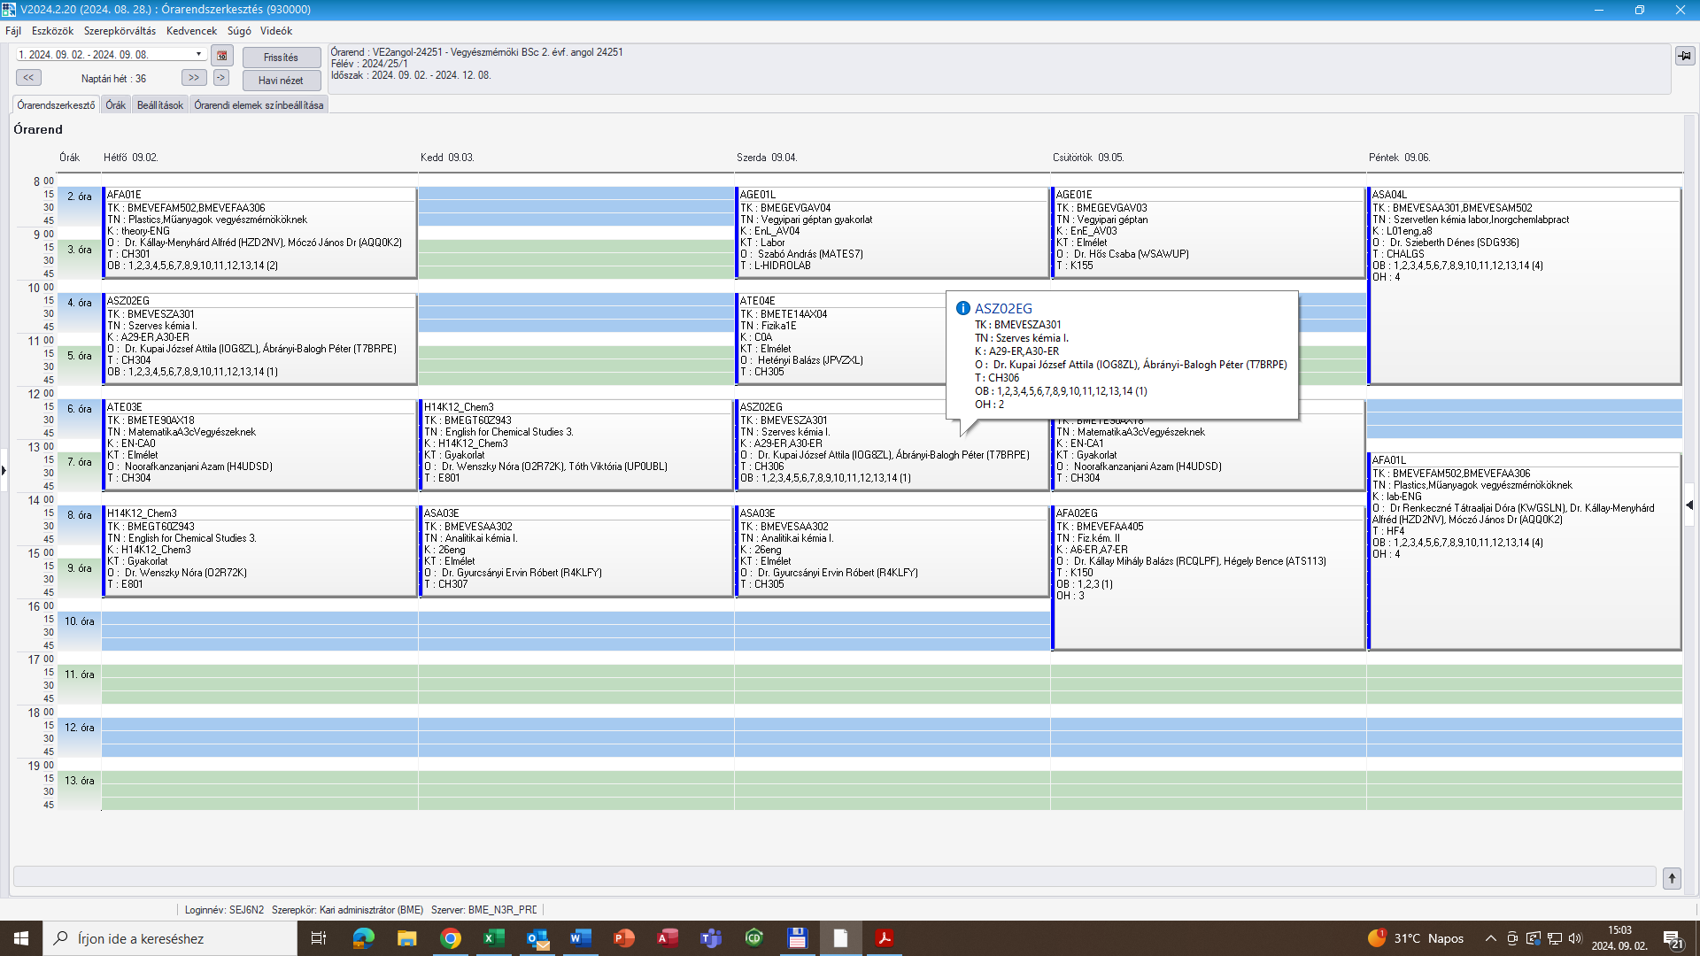

Industrial Pharmaceutics specialization

Subject code | Subject name | Lecturer(s) | Curse code | type |  | cr | theo | pract | lab | Schedule
BMEVEFAA506 | Physical Chemistry Laboratoy Practice | Dr. Benjámin Sándor Gyarmati | A0 | lab | p | 3 | 0 | 0 | 4 | Th:08:15-12:00(F11FK)
BMEGT55A001 | Business Law | Dr. Anikó Grad-Gyenge, Dr. Zoltán Víg, Borbála Vörös | EEN15BM | theo | p | 2 | 2 | 0 | 0 | Fr:12:15-14:00 (QB104)
BMEVEVMA606 | Design of Experiments | Dr. Kinga Komka, Dr. Máté Mihalovits, Dr. Éva Pusztai | elm_Eng-ER, gyak_Eng-ER | theo | p | 3 | 2 | 1 | 0 | Th:16:15-19:00(CH308)
BMEVEKFA512 | Chemical Unit Operations II | Dr. Edit Éva Székely, Márton Kőrösi, Saled Ahmad Ghazwan | elm_ENG_ER, gyak_ENG_ER | pract | e | 6 | 2 | 1 | 4 | Th:12:15-15:00(CH 307)
BMEVEKFA512 | Chemical Unit Operations II | Dr. Tivadar Farkas, Firoozirad Khadjeh, Dr. Edit Éva Székely | lab_ENG | lab | e | 6 | 2 | 1 | 4 | Mo:08:15-11:00(DFhall)
BMEVEKFA506 | Hydrocarbon technology | Dr. András Holló, Dr. Iván László Gresits, Dr. Ágnes Szanyi | elm_ENG | theo | e | 3 | 2 | 0 | 1 | We:10:15-12:00 (CH302)
BMEVEKFA506 | Hydrocarbon technology | Dr. Iván László Gresits | lab_ENG | lab | e | 3 | 2 | 0 | 1 | We:13:15-16:00 (F2ALGS)
BMEVEBEA301 | Biochemistry | Dr. Szilveszter Gergely, Dr Tamás Lőrincz, Dr. András Szarka | A12 | theo | e | 4 | 3 | 0 | 0 | Mo:15:15-18:00(CH A11)
BMEVESAA512 | Organic Structure Analysis | Dr. Zsuzsanna Sánta | E18eng | theo | p | 3 | 3 | 0 | 0 | Tu:17:15-19:00 (CH304)
BMEVESKA605 | Organic Chemistry Laboratory Practice II | Dr Gábor Hornyánszky, Balázs Kenéz | AG6, AL6 | pract | p | 5 | 0 | 0 | 6 | Tu:08:15-14:00(CH207)
BMEVESTA508 | Unit Processes of Organic Chemistry | József Schindler | 26a | theo | e | 2 | 2 | 0 | 0 | Fr:10:15-12:00 (F2M012)

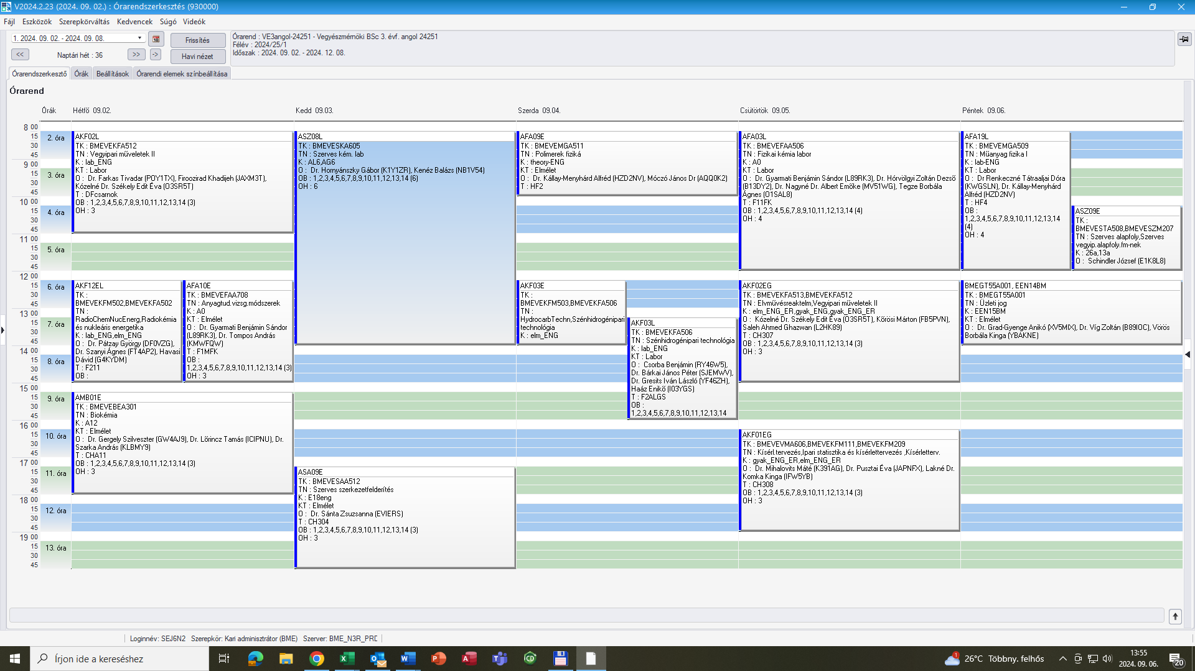

Materials Science specialization

Subject code | Subject name | Lecturer(s) | Curse code | type |  | cr | theo | pract | lab | Schedule
BMEVEFAA506 | Physical Chemistry Laboratory Practice | Dr. Benjámin Sándor Gyarmati | A0 | lab | p | 3 | 0 | 0 | 4 | Th:08:15-12:00(F11FK)
BMEGT55A001 | Business Law | Dr. Anikó Grad-Gyenge, Dr. Zoltán Víg, Borbála Vörös | EEN15BM | theo | p | 2 | 2 | 0 | 0 | Fr:12:15-14:00 (QB104)
BMEVEMGA511 | Polymer Physics | Dr. Alfréd Kállay-Menyhárd, Dr. János Móczó, Dr. Dóra Tátraaljai | theory-ENG, lab-ENG | theo | e | 3 | 2 | 0 | 0 | theory: We:08:15-10:00 (HF2)  lab: Fr:08.15-12:00 (HF4)
BMEVEFAA708 | Experimental Methods in Materials Science | Dr. András Tompos, Dr. Benjámin Gyarmati | A0 | theo | p | 4 | 3 | 0 | 0 | Mo:12:15-15:00 (F1MFK)
BMEVEVMA606 | Design of Experiments | Dr. Kinga Komka, Dr. Máté Mihalovits, Dr. Éva Pusztai | elm_Eng-ER, gyak_Eng-ER | theo, pract | p | 3 | 2 | 1 | 0 | Th:16:15-19:00(CH308)
BMEVEKFA512 | Chemical Unit Operations II | Dr. Edit Éva Székely, Márton Kőrösi, Saled Ahmad Ghazwan | elm_ENG_ER, gyak_ENG_ER | pract | e | 6 | 2 | 1 | 4 | Th:12:15-15:00(CH 307)
BMEVEKFA512 | Chemical Unit Operations II | Dr. Tivadar Farkas, Firoozirad Khadjeh, Dr. Edit Éva Székely | lab_ENG | lab | e | 6 | 2 | 1 | 4 | Mo:08:15-11:00(DFhall)
BMEVEKFA506 | Hydrocarbon technology | Dr. András Holló, Dr. Iván László Gresits, Dr. Ágnes Szanyi | elm_ENG | theo | e | 3 | 2 | 0 | 1 | We:10:15-12:00 (CH302)
BMEVEKFA506 | Hydrocarbon technology | Dr. Iván László Gresits | lab ENG | lab | e | 3 | 2 | 0 | 1 | We:13:15-17:00 (F2ALGS)
BMEVEBEA301 | Biochemistry | Dr. Szilveszter Gergely, Dr Tamás Lőrincz, Dr. András Szarka | A12 | theo | e | 4 | 3 | 0 | 0 | Mo:15:15-18:00(CH A11)

Industrial Pharmaceutics specialization

Subject code | Subject name | Lecturer(s) | Curse code | type |  | cr | theo | pract | lab | Schedule
BMEVEKFA615 | Quality Management | Dr. Vivien Surman,  Dr. Kinga Komka, Éva Pusztai | elm_ENG | theo | p | 4 | 3 | 0 | 0 | Tu14:15-17:00(CH 304)
BMEVESTA704 | Pharmaceutical technology | Dr. Zsolt Rapi,  Dr. Zoltán Hell | 26a | theo | p | 2 | 2 | 0 | 0 | Mo:10:15-12:00 (F2M012)
BMEVESZA777 | Planning | Dr. Erika Bálint | 14a | practice | p | 3 | 0 | 1 | 0 | Mo: 12.15-14:15(F2M012)
BMEVESTA705 | Unit processes in Industrial Drug Synthesis Laboratory Practice | Dr. Zoltán Hell | 17a | practice | p | 4 | 0 | 0 | 5 | We:10:15-15:00
BMEVExxA999* | Thesis |  |  |  | p | 15 | 0 | 0 | 15
*The code depends on the supervisor’s department

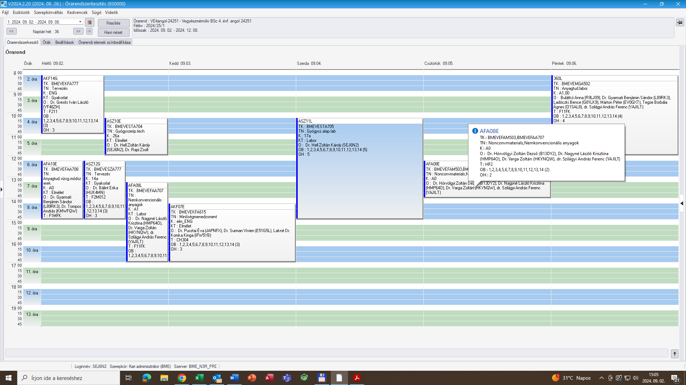

Materials Science specialization

Subject code | Subject name | Lecturer(s) | Curse code | type |  | cr | theo | pract | lab | Schedule
BMEVEKFA615 | Quality Management | Dr. Vivien Surman,  Dr. Kinga Komka, Éva Pusztai | elm_  ENG | theo | p | 4 | 3 | 0 | 0 | Tu14:15-17:00(CH 304)
BMEVEMGA502 | Experimental Methods in Materials Science Lab | Dr. András Szilágyi, Dr. Benjámin Gyarmati | A1 | theo | p | 3 | 0 | 0 | 4 | Fr:08:15-12:00(F11FK)
BMEVEFAA777 | Planning | Dr. Alfréd Kállay-Menyhárd |  |  | p | 3 | 0 | 1 | 0
BMEVEFAA707 | Nonconventional Materials | Dr. András Szilágyi, Dr. Krisztina László, Dr. Zoltán Varga | A0 | theo | p | 3 | 2 | 0 | 1 | Th:12:15-14:00 (HF2)
BMEVEFAA707 | Nonconventional Materials | Dr. András Szilágyi, Dr. Krisztina László, Dr. Zoltán Varga | A1 | laboratory | p | 3 | 2 | 0 | 1 | Mo:13:15-17:00 (F11FK)
BMEVExxA999* | Thesis |  |  |  | p | 15 | 0 | 0 | 15

*The code depends on the supervisor’s department

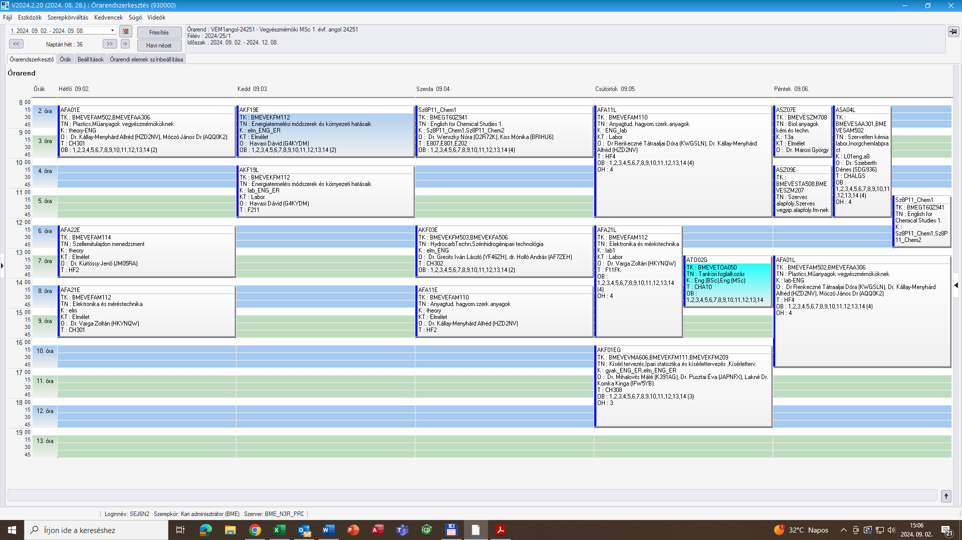

Subject code | Subject name | Lecturer(s) | Course code | type |  | cr | theo | pract | lab | Schedule
BMEGT20M005 | Technology Management | Dr. Béla Pataki | EEN04VE | theo | p | 2 | 2 | 0 | 0 | Tu:12:15-14:00 (CH A11)
BMEVEKFM402 | Petrochemistry | Dr. Iván László Gresits | lab_ENG | lab | e | 6 | 2 | 0 | 3 | We:08:15-19:00
BMEVEKFM402 | Petrochemistry | Dr. Iván László Gresits, Dr. Ákos Fürcht | elm_ENG | theo | e | 6 | 2 | 0 | 3 | We:12:15-14:00  (CH 302)
BMEVESAM206 | Quality Control | Dr. László Károly Bezúr | 16A | theo | p | 2 | 2 | 0 | 0 | Fr:13:15-15:00(CH 302)
BMEVESZM207 | Unit Processes of Organic Chemistry | József Schindler | 11a | theo | p | 3 | 0 | 2 | 0 | Fr:10:15-12:00  (F2M012)
BMEVExxM300* | Thesis Project I |  |  |  | p | 15 | 0 | 0 | 11

*The code depends on the supervisor’s department

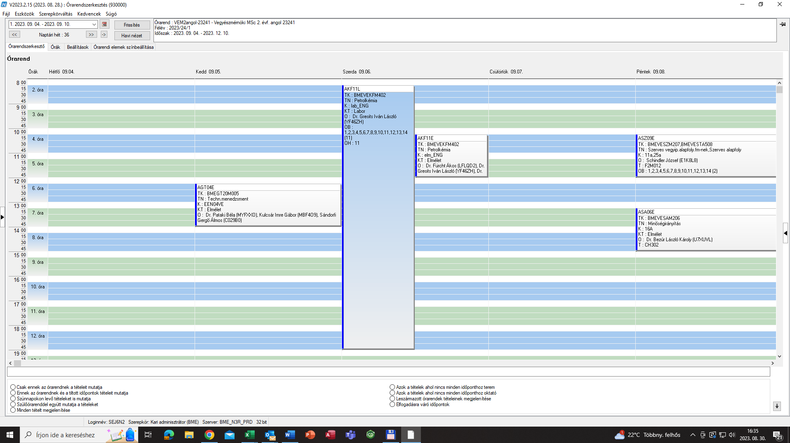

Electives

Subject code | Subject name | Lecturer(s) | Course code | type |  | cr | theo | pract | lab | Schedule
BMEVESZM704 | Biocatalysis | Dr. László Poppe | 14-ER | theo | p | 2 | 2 | 0 | 0 | Tu:15:15-17:00  (CH 301)
BMEVEFAM502 | Plastics | Dr. Alfréd Kállay-Menyhárd | theory_ENG | theo | p | 5 | 2 | 0 | 2 | Mo:8:15-10:00  (CH 301)
BMEVEFAM502 | Plastics | Dr. Alfréd Kállay-Menyhárd | lab-ENG | lab | p | 5 | 2 | 0 | 2 | Fr:13:15-17:00(HF4)
BMEVEFAM212 | Biopolymers | Dr. Emilia Csiszár | theory-ENG, | theo | e | 4 | 2 | 0 | 1 | Mo:10:15-12:00(HF2)
BMEVEFKAKM1 | Physical Chemistry and Radiochemistry | Dr. Krisztina László | A0-ER | theo | p | 3 | 2 | 0 | 1 | Th:08:15-10:00(CH306)
BMEVEFKAKM1 | Physical Chemistry and Radiochemistry | Dr. Krisztina László | A1-ER | lab | p | 3 | 2 | 0 | 1 | We:16:15-19:00(F11FK)
BMEVEFAM503 | Nonconventional Materials | Dr. András Ferenc Szilágyi, Dr. Krisztina László | A0 | theo | p | 3 | 2 | 0 | 0 | Th:12:15-14:00(HF2)
BMEVEKFM503 | Hydrocarbon technolgy | Dr. András Holló, Dr. Iván László Gresits, Dr. Ágnes Szanyi | elm_  ENG | theo | e | 3 | 2 | 0 | 0 | We:10:15-12:00(CH302)
BMEVEKFM402 | Petrochemistry | Dr. Iván László Gresits | lab_  ENG | lab | e | 6 | 2 | 0 | 3 | We:08:15-19:00
BMEVEKFM402 | Petrochemistry | Dr. Ákos Fürcht, Dr. Iván László Gresits | elm_  ENG | theo | e | 6 | 2 | 0 | 3 | We:12:15-14:00  (CH 302)
BMEVEMBM501 | Environmental Toxicology | Dr. Viktória Dóra Feigl, Dr. Mónika Molnár | A13, A14 | theo, lab | p | 3 | 1 | 0 | 1 | Tu:10:15-13:00  (CH 301)
BMEVESAM502 | Inorganic Chemistry Laboratory Practice | Dr. Dénes Szieberth | L01eng.a8 | lab | p | 3 | 0 | 0 | 4 | Fr:8:15-12:00  (CHALGS)
BMEVESAM503 | Chromatography | Dr József Balla, Dr. Blanka Tóth | 08 | theo | e | 3 | 2 | 0 | 0 | Th:10:15-12:00  (CH305)
BMEVESZM207 | Unit Processes of Organic Chemistry | József Schindler | 13a | theo | p | 3 | 0 | 2 | 0 | Fr:10:15-12:00(F2M012)
BMEVEKFM502 | Radiochemistry and Nuclear Energetics | Dr György Pátzay, Dr. Ágnes Szanyi | lab_  ENG, elm_  ENG | theo, lab | p | 3 | 2 | 0 | 1 | Mo:12:15-15:00 (F211)

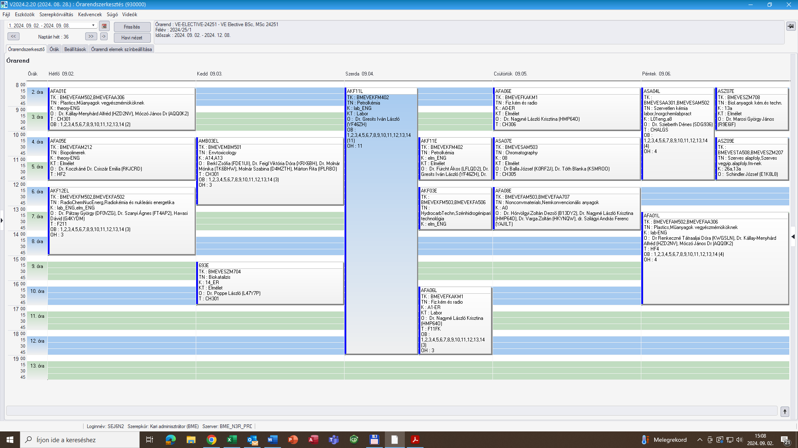

Erasmus

